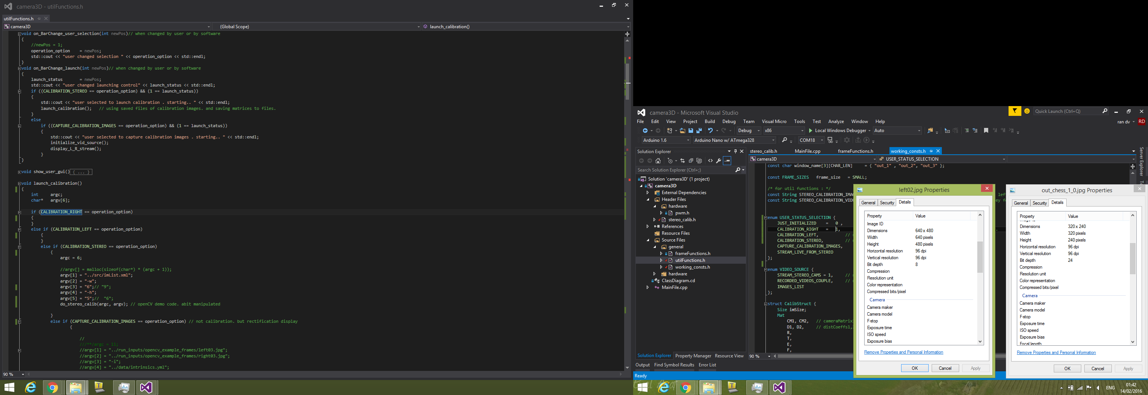

Opencv works well.

Mine is garbage!